Lesson 8 Demo 1: Access Kubernetes Cluster from Docker CLI

This section will guide you to:

* Download the client bundle from MKE
* Configure *kubectl* on the Terminal using the client bundle

**Note:** You can perform this demo with MKE web UI, provided you've a license for it. However, Mirantis isn't providing the free license currently, leading to limited or disabled use of some of the MKE features.

**Step 1:** Download the client bundle from MKE

* Navigate to MKE dashboard and click on **Docker CLI** information box

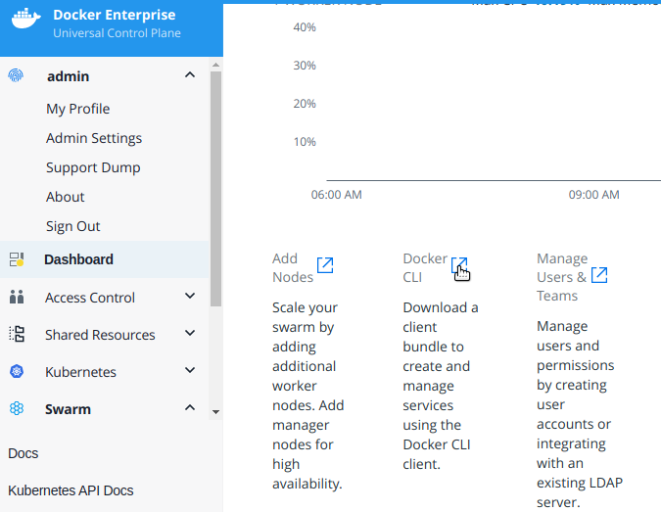

* On the **Create and Manage Services Using the CLI** window, click on **user profile page**

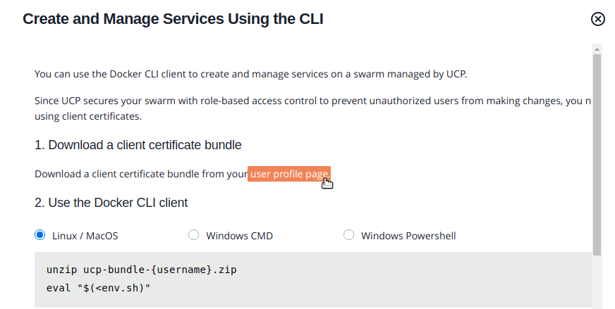

* On the **Profile** page, click on the **New Client Bundle** dropdown to select **Generate Client Bundle** and click on the **Confirm** button

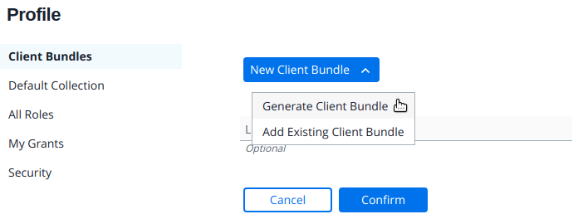

**Step 2:** Configure kubectl on the Terminal using the client bundle

* On the master node, open the Terminal and navigate to the Downloads folder to list the zipped client bundle

*cd Downloads*

*ls*

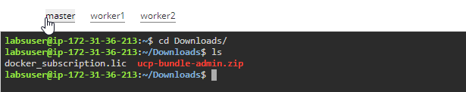

* Run the following command to extract the environment script and execute it

*unzip ucp-bundle-{username}.zip*

*eval "$(<env.sh)"*

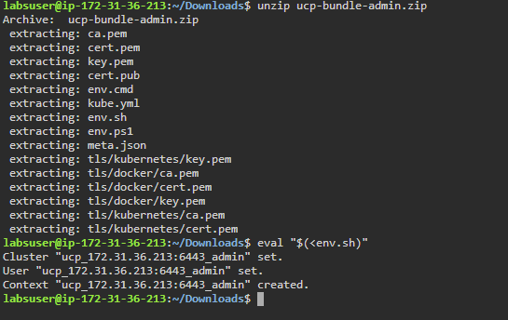

* Use the following command to check the nodes on the Kubernetes cluster:

*kubectl get nodes*

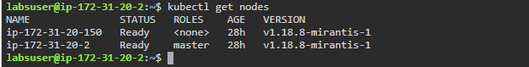

* Create a deployment using the **kubectl** command and list the pod for this deployment

*kubectl create deployment nginx --image=nginx*

*kubectl get pods*

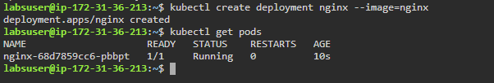

* Navigate back to the MKE dashboard and click on the **Pods** under **Kubernetes** section to see the newly created pod

